

A Guide to Safeguarding at Roseberry Primary School

No school operates in isolation. Keeping children safe from significant harm is the responsibility of all adults especially those working with children.
Roseberry Primary School is committed to keeping children safe and safeguarding all children in accordance with Child Protection: Hartlepool and Stockton-on-Tees Safeguarding Children Partnership https://hsscp.co.uk/ and partner agencies in all cases where there is a concern about significant harm.



All staff are expected to read, understand and follow:
Keeping Children Safe in Education 2026 Part One
Extol Trust Safeguarding and Child Protection Policy
Extol Trust Staff Code of Conduct
All staff undertook safeguarding training, commensurate to their role, September 2026

As a member of staff, you have a responsibility to:

- Consider, at all times, what is in the best interests of the child.
- Maintain an attitude of ‘it could happen here’ where safeguarding is concerned and report any concerns regarding the behaviour of a child, an adult / staff member in school, directly to the DSL/HT. (If the concern is with regard to the headteacher, it will be referred to the CEO)
- Provide a safe environment in which children can learn.
- Be prepared to identify pupils who may benefit from Family Help.
- Be aware of the school’s systems which support safeguarding, including any policies, procedures, information and training provided upon induction.
- Be aware of the role and identity of the DSL and deputy DSLs.
- Undertake safeguarding training, including online safety training (which, amongst other things, includes an understanding of the expectations and responsibilities relating to filtering and monitoring), during their induction – this will be regularly updated.
- Receive and understand child protection and safeguarding (including online safety) updates, e.g. via email, as required, and at least annually.
- Be aware of the local Family Help process and understand their role in it.
- Be aware of, and understand, the process for making referrals to CSCS, as well as for making statutory assessments under the Children Act 1989 and their role in these assessments.
- Make a referral to CSCS and/or the police immediately, if at any point there is a risk of immediate serious harm to a child.
- Support social workers in making decisions about individual children, in collaboration with the DSL.
- Be aware of and understand the procedure to follow in the event that a child confides they are being abused, exploited or neglected.
- Be aware that a pupil may not feel ready or know how to tell someone that they are being abused, exploited or neglected, and/or may not recognise their experiences as harmful.
- Promote dialogue and understanding, and ensure all pupils feel listened to and understood.
- Empower pupils and allow them to understand their rights to safety and privacy, and to help them understand what they can do to keep themselves protected from harm.
- Avoid victim-blaming attitudes and challenge it in a professional way if it occurs.
- Maintain appropriate levels of confidentiality when dealing with individual cases.
- Reassure victims that they are being taken seriously, that they will be supported, and that they will be kept safe.
- Speak to the DSL if they are unsure about how to handle safeguarding matters.
- Be aware of safeguarding issues that can put pupils at risk of harm.
- Be aware of behaviours that could potentially be a sign that a pupil may be at risk of harm.

Teachers, including the Headteacher, have a responsibility to:

- Safeguard children’s wellbeing and maintain public trust in the teaching profession as part of their professional duties, as outlined in the ‘Teachers’ Standards’.
- Personally report any cases to the police where it appears that an act of FGM has been carried out, also referred to as ‘known’ cases, as soon as possible.

Actions where there are concerns about a child (from KCSIE 2026)
The DSL/Deputy DSL will be informed immediately by an employee of the school, child who attends the school, parent/carer of the school or other persons, in the following circumstances:
- Suspicion that a child is being harmed
- There is evidence that a child is being harmed
- The threshold of significant harm is defined in the Children Act 1989 Section 31 (9) as:
- Ill-treatment
- Impairment of health (as compared to a similar child)
Note: harm now includes the impairment of a child’s health or development as a result of witnessing the ill-treatment of another person (Adoption and Children Act 2002).
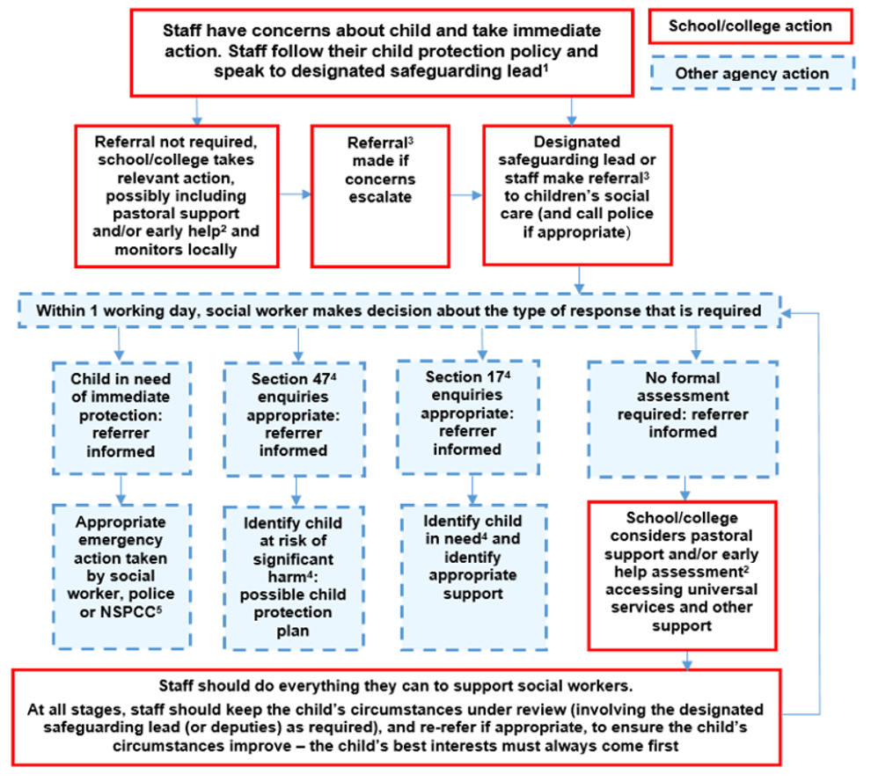
(Ref: KCSIE, 2026 Page 27)
- In cases which also involve a concern or allegation of abuse against a staff member, see Part four of KCSIE 2026.
- Family Help means providing support as soon as a problem emerges at any point in a child’s life. Where a child would benefit from co-ordinated Family Help, a family help inter-agency assessment should be arranged. Working Together to Safeguard Children provides detailed guidance on the Family Help process.
- Referrals should follow the process set out in the local threshold document and local protocol for assessment. See Working Together to Safeguard Children.
- Under the Children Act 1989, local authorities are required to provide services for children in need for the purposes of safeguarding and promoting their welfare. Children in need may be assessed under section 17 of the Children Act 1989. Under section 47 of the Children Act 1989, where a local authority has reasonable cause to suspect that a child is suffering or likely to suffer significant harm, it has a duty to make enquiries to decide whether to take action to safeguard or promote the child’s welfare. Full details are in Working Together to Safeguard Children.
- This could include applying for an Emergency Protection Order (EPO).

Actions were there are concerns about a child: Reporting and Referral Process
The process outlined within the first section should be followed where a staff member has a safeguarding concern about a child. Where a referral has been made, the process outlined in the ‘After a referral is made’ section should be followed.
The actions taken by the school are outlined in yellow, whereas actions taken by another agency are outlined in blue.
Before a referral is made
N
A staff member identifies a concern or potential concern. Is the pupil at immediate risk of harm?

Is the DSL or deputy DSL available to discuss the concern with?
The staff member immediately notifies the police of the situation and informs the DSL.
The staff member makes a referral to CSCS, notifying the DSL of this as soon as possible.
The staff member discusses the concern with the DSL. Taking into account observations and using professional judgement, is a referral required?
The DSL makes a referral to CSCS, keeping the staff member who raised the concern up-to-date with what action is taken.
The pupil continues to be monitored and family help is provided where necessary. If the concern escalates, a referral is made to CSCS.
Within one working day, a social worker from CSCS will make a decision about the type of response that is required and will notify the referrer. Where this information is not forthcoming, the referrer should contact the appointed social worker to follow up the referral.
The steps outlined in the next flowchart are then followed.
N
N
Y
Y
Y

After a referral is made
Once a referral has been made, a social worker from CSCS will notify the referrer that a decision has been made and one of the following responses will be actioned.
The pupil is in need of immediate protection.
Where the pupil is at risk of significant harm but is not in immediate danger, a strategy discussion is held.
No formal assessment is needed.
Where appropriate to do so, the DSL and staff member who raised the concern may be consulted during these stages to ensure that all areas of concern are addressed.
The DSL supports the initial staff member to liaise with other agencies to arrange a family help assessment and appropriate support.
A Child in Need assessment is completed within 45 working days.
Within 15 working days of the strategy discussion, an initial child protection conference is held.
A child protection plan is potentially required.
Appropriate emergency action is taken by the social worker, police or NSPCC.
If the child’s situation does not appear to be improving, the DSL should press for re-consideration to ensure their concerns have been addressed and, most importantly, that the child’s situation improves.
Staff keep the pupil’s circumstances under review and re-refer if appropriate to ensure circumstances improve – the pupil’s best interests always come first.
The type of support needed is identified, arranged through multi-agency liaison and provided effectively.

Contact Details
Christian Park (Executive HT)  Roseberry@roseberryprimary.org.uk | Deanne Richardson (Head of School)  Designated Safeguarding Lead  Roseberry@roseberryprimary.org.uk
  Linda Hollinshead (AHT)  Designated Deputy for Safeguarding  Roseberry@roseberryprimary.org.uk | Aimee Fleming (Office/Attendance Manager)  Designated Deputy for Safeguarding  Roseberry@roseberryprimary.org.uk
  Craig Nicholson  Extol Trust CEO  enquiries@extoltrust.co.uk | Mr Bill Walton  Safeguarding Governor  Roseberry@roseberryprimary.org.uk
Hartlepool and Stockton-on-Tees Safeguarding Children Partnership
Telephone: 01429 284284

Stockton-on-Tees Local Authority Designated Officer (LADO)
Telephone: 01429 401844
Email: LADO@hartlepool.gov.uk

